Operator Misuse Form
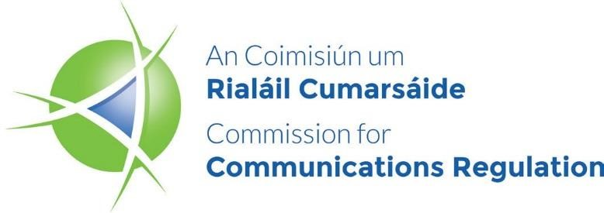

Fraudulent and/or Misuse of Numbering Resources - Regulation 83(2) Process

Primary Operator Misuse Notification Form
Please complete the form as per guidance in ComReg 18/119R (An Operator’s Note) and return to ComReg no later than 15 calendar days after incident is detected and stopped.
Failure to provide the relevant information in a timely manner may result in ComReg being unable to take action in relation to the case.
Operator contact details
(name and address)
Retail operator (if different from above)
End-user business name and Address
End-user Contact Name
Garda Reference Number
Call Details | To be sent electronically on excel spread sheet
Wholesale costs for Relevant Calls
(€) (ex VAT)
Retail costs for Relevant Calls (€) (ex VAT)
Average Monthly Retail Bill (€) (ex VAT)
(if Wholesale costs < €5,000)
Interconnection Operators in Ireland
Interconnection Operators Outside Ireland
Portion of costs assigned to each interconnect operator
Date/s that payment is due on the relevant calls to Interconnect Operators
Do you maintain the security of the PBX?
Is the PBX physically located in the customer premises? If it is, who installed and who maintains the PBX?
What costs will you charge the end-user if ComReg intervenes?
What costs will you charge the end-user if ComReg does not intervene?

